- A Harvest of the Best … from Across the Nation
National Ag in the Classroom Conference 2010
Resource Submission Form
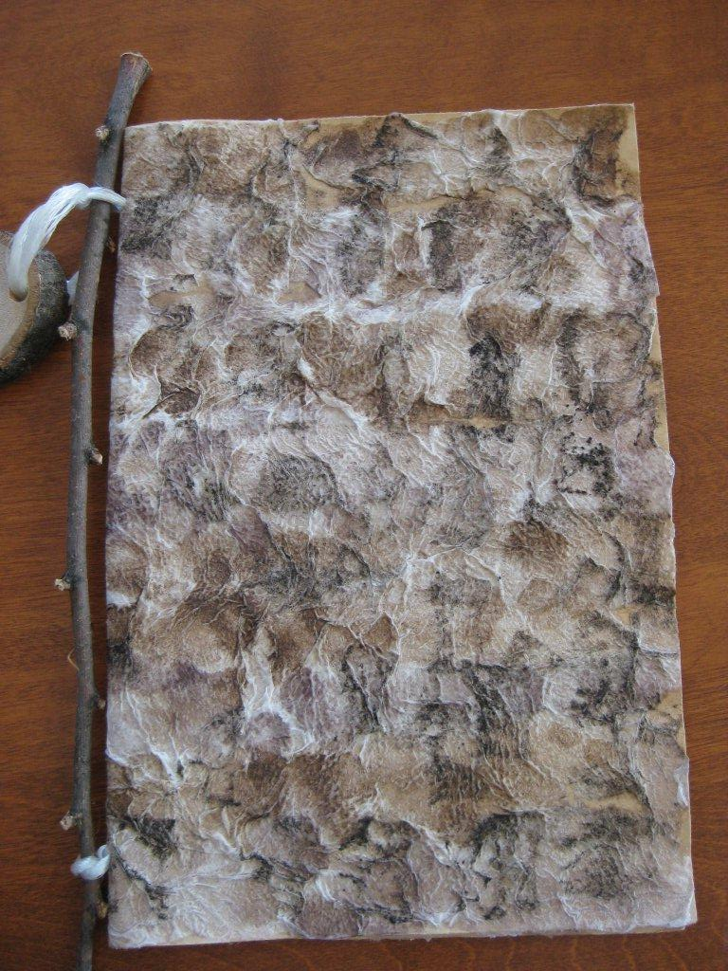

State: North Dakota

Circle Appropriate Category

Book & Activity

Title: Birch Bark Journal Painted with
State Soils

Subject: Art

Skills:

Grade Level: 3-12

Length of Lesson/Activity: Two sessions: 1st session approximately 1 hour plus overnight to dry
2nd session approximately 30 minutes

Overview: Create this wonderfully realistic book cover for students to use as a journal or book cover. When painted with soils from their state, the book is a perfect showcase for agriculture! The finished product has the look and feel of finely layered birch bark and teachers would agree that it is a wonderful way for their students to develop a “Know Your State” book.

The book is created by placing strips of torn toilet paper on a sheet of construction paper and which are held in place with watered down glue. The toilet paper can be textured lightly with the brush to give it a rough looking finish. Next, the books can be painted using various colors of finely ground soils which are also mixed in with watered down glue and lightly painted on. The pages must be allowed to lay flat and dry overnight. (Do not place on newspapers or other porous surface because the glue mixture will adhere to the paper) The following day, after the project is dry, the 8 ½ x 11” page is folded in half and can be hole punched to hold the inside pages. Utilizing a twig and twine as binding will make the book look even more authentic.

Materials needed:
Grey construction paper (1 per student) 8 ½” x 11” for a small journal or 11” x 17” for a full size book.
Elmer’s Glue mixed with 2 parts water
Roll of toilet paper (separate at every third perforation – enough for each student to have about three strips of this length)
Bowl for glue/water mixture
Bowls for students (can be shared)
Paintbrushes for students… ¼” - ½” work well
Plastic table covers, if desired
Various soils, prepared for painting (very finely ground and sifted)
If the soil pigments are all dark, water paints may be used for additional color.

Teaching the Lesson:
The teacher will need to prepare a mixture of watered down glue of about two parts water to one part glue. It does not take much and the mixture can be sealed in a jar to use again. Place some of the mixture in separate bowls to be used for adding soil to do the painting. Experiment with the amount of soil to achieve color, but not grit!

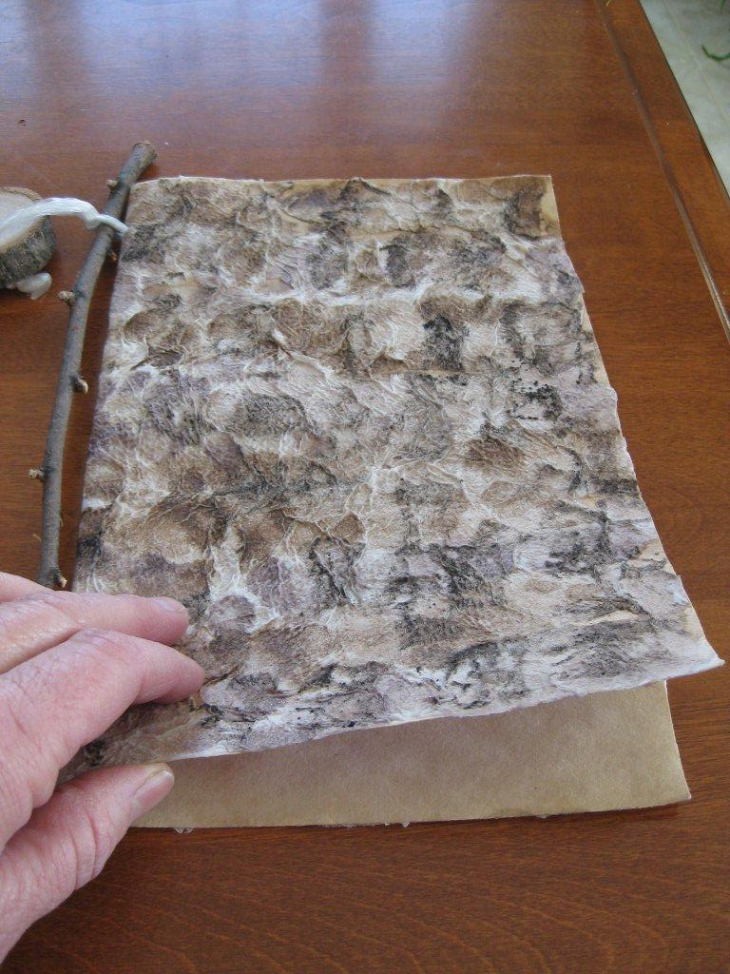
Provide each student with a single piece of 8 ½ x 11 construction paper…. Light grey works best. ASK THEM TO INITIAL OR WRITE THEIR NAME ON THE BACKSIDE SO THEY CAN FIND THEIR OWN BACK SHOULD THEY BECOME GROUPED. Having the paper horizontal, each student will tear their lengths of toilet paper (3 Squares Long) in thirds and lay them across the paper so it is covered. Then they use their brushes and watered down glue to wet/texture the toilet paper to the page. After they have the toilet paper in place they can begin painting their books with the different types of soil that is also mixed with watered down glue. A variety of colors makes for a very unique and interesting looking book cover.

If possible, the painted pages should just be left to dry without moving. The following day the pages are folded in half and hole punched at the top and bottom of the fold. A piece of twine can be used to string through the holes and attach any pages that are placed inside.

Lesson Developed by:
North Dakota AITC & ND Farm Bureau
**Utilized in our Project Food, Land & People Workshops
Ginger Deitz, Jill Vigesaa & Gail Bakko

Your e-mail address:
Gail Bakko gails@ndfb.org
Virginia Deitz deitzv@fargo.k12.nd.us
Jill D. Vigesaa jill.vigesaa@ideaone.net

