TO: County Presidents & Secretaries
FROM: Fargo Office
DATE: February 3, 2026
RE: Suggested Agenda for February, 2026

- Call to Order
  - Pledge of Allegiance
- Reading of Minutes
- Financial Report – Motion to “receive & file” the report
- Issues Discussion—The state recently secured $199 million in federal funding through the Rural Health Transportation Program, approved during the 69th Special Session. This funding will roll out as multiple grant opportunities through the North Dakota Health Department. Go to https://www.hhs.nd.gov and click on the Rural Health Transformation Tab for more information. The grants are aimed at practical, locally driven solutions to support rural communities, focusing on four main areas: strengthening the rural health workforce, improving overall health outcomes, bringing quality health care closer to home, and better connecting technology, data, and providers across the state. As this unfolds, it’s worth talking about what solutions can come from the ground up, led by counties, local organizations, and private people—rather than waiting on state programs. What are some practical things our county or local groups could do right now to improve rural health and rural mental health? Are there existing church efforts, businesses, or community initiatives we could plug into or help move forward, with or without federal dollars?
- Report from NDFB Staff
- Committee Reports - Committees can include non-board members
  - Resolutions, Membership, YF&R, Publicity, P&E
- Old Business
- New Business
- 990 or 990EZ or 990-N, 990 T, and ND Form 40 are due 2/15/2026 if 9/30 is the year-end date. Remember that the IRS requires non-profits with less than $50,000 in Gross Receipts to file the 990-N electronically through the IRS website.
- Social Security administration copies of W2’s must be postmarked by February 28, 2026 for paper filings and March 31, 2026 for electronic filings.
- IRS 1099 copies need to be postmarked by January 31, 2026.
- Not-For-Profit report to Secretary of State Office due 1/31/2026.
- Plan to hold a membership recruitment activity, such as a BBQ, sometime throughout the year, inviting prospective members.
- During March 8-14, 2026, we will celebrate NDFB Week. This year's theme is "Harvesting Hope: For Healthy Minds and Safer Farms."
Ideas for the week include:
- Posting an ad in your local paper
- Do a meat giveaway at your local grocery store or a shop
- Free Meat Monday – sponsor free hamburgers at a local restaurant
- Create a Message of Hope Board
- Sponsor free coffee at a local coffee shop
- Trivia contest on your local radio station
- Promote the drawing contest
Drawing Contest Details:
To highlight the important role we can all play in fostering safety and resiliency on the farm, our drawing contest for students in grades 4 and 5 will ask them to show how "Farm Safety Starts With Me."
The deadline for the state drawing contest is March 4.
- Please submit your 2026 county leader contact information to Amy Neurohr in the Bismarck office by February 13th. You must send changes to your county Farm Bureau leadership throughout the year to Amy so the Leadership Directory can stay up to date.
- NDFB scholarship applications are available online at www.ndfb.org/edusafe and are due in the NDFB office in Fargo on March 1, 2026.
- During each Young Farmer and Rancher committee's term, they are required to host a district event. It is helpful when a board member from each county sits on the 'district committee.' These district events can be whatever the county decides. Some ideas from the past include golf outings, trap shooting, baseball games, Stiklestad Lodge, pumpkin patch, speakers, and farm/industry tours.
- NDFB is excited to announce NDFB's partnership with Ohnstad Twichell, P.C., to provide comprehensive legal education for our members in 2026! Harvesting Legal Knowledge, is a collaborative video series between NDFB and Ohnstad Twichell Law firm. The goal of the series is to address key topics that affect farmers, ranchers, and ag businesses every day. Check it out at www.ndfb.org/harvesting-legal-knowledge
- The NDFB Foundation Spring Harmony Gala will take place on March 13, 2026, at the Holiday Inn in Fargo, closing out NDFB Week. This event brings together the key leaders and influencers in North Dakota agriculture. We encourage County Farm Bureaus to send active members to connect with these movers and shakers, share the impact of the NDFB Foundation, and personally encourage support through auction item donations, sponsorships, or contributions.
Tickets are available for purchase. Please scan the QR code below for quick and easy registration. Your involvement, whether through attendance, donation, or sponsorship, helps ensure the continued success of the Foundation and its mission. Thank you for your continued support!
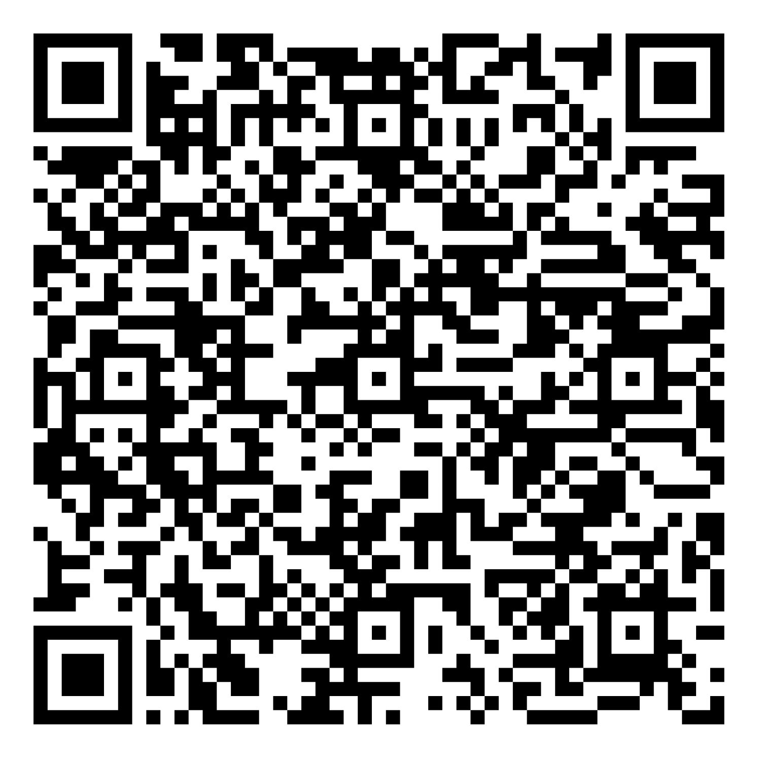
- If you are an NDFB family farmer or small business owner and are able to hire your spouse as an employee of your business, AgriPlan or BizPlan can help you and your family save thousands of dollars each year. As of January 1, 2017, qualified businesses (more than one employee but fewer than 50) that do not offer group health insurance but want to assist their employees with ever-rising healthcare costs will be able to use tax-advantaged funds to reimburse employees for individual insurance and out-of-pocket medical expenses. Please contact Dan Pavek, who is part of our knowledgeable team, for more information and to discuss your options. Dan Pavek | Regional Sales Director Dan.pavek@tasconline.com (C) 701-351-5669
- Win the bin! Don’t forget to register to win a $1,000 3D-printed gran bin setup! Click on the following link to sign up and for more information: https://www.ndfb.org/win-the-bin/
- Giving Hearts Day is right around the corner on February 12, and we want to take a moment to highlight this important opportunity to support the NDFB Foundation and the meaningful work it does on behalf of agriculture, education, and leadership development across North Dakota. Early giving is now open and runs through February 11, so you can make your gift at a time that is convenient for you, or you may choose to give on Giving Hearts Day itself on February 12. Every donation—large or small—makes a difference and helps strengthen the NDFB Foundation's mission. https://www.ndfb.org/foundation/foundation-news/early-donations-are-open-for-giving-hearts-day/
Calendar of Events
Feb 12, 2026 Giving Hearts Day for NDFB Foundation
Mar 8-14, 2026 NDFB Week
Mar 11, 2026 Last day to enter the drawing to win the bin
Mar 13, 2026 NDFB Foundation Spring Harmony Gala – Fargo

Spring Route 1000 classes are coming soon! Be sure to check out NDFB’s events page!

